Religious Studies

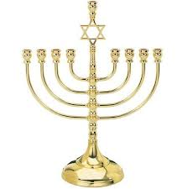

A nine-branched candle lit during the eight-day Jewish holiday of Hanukkah. On each night of Hanukkah, a new branch is lit.

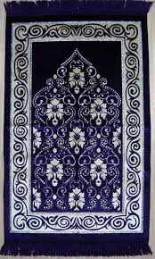

A prayer rug or prayer mat is a piece of fabric, sometimes a carpet, used by Muslims, placed between the ground and the worshipper for cleanliness during the various positions of Islamic prayer. ... All Muslims are required to know the qibla or direction towards Mecca from their home or where they are while traveling

The meaning of the 5 Ks

A simple, plain circular steel bracelet Kara - a steel bracelet

The 5 Ks taken together symbolise that the Sikh who wears them has dedicated themselves to a life of devotion and submission to the Guru. The 5 Ks are 5 physical symbols worn by Sikhs who have been initiated into the Khalsa.

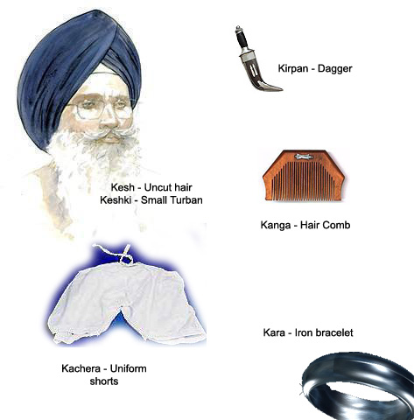

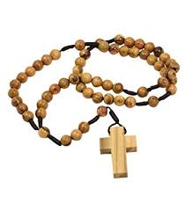

The rosary beads help Christians keeping count of the number of Hail Marys said. The fingers are moved along the beads as the prayers are read.

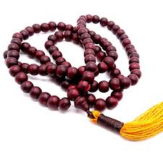

Buddhist prayer beads or malas are a traditional tool used to count the number of times a mantra is recited, breaths while meditating, counting prostrations, or the repetitions of a buddha's name.

Puja thali (in English: Prayer plate or Puja plate) is a tray on which the entire puja materials are decorated. The tray is used in most Hindu festivals and traditions These items include: A bell to alert God to the prayer. incense to purify the air around the shrine. Offerings of fruit, flowers and money

